**Introduction:**

**What is Fuzzy Search?**

* A technique of finding the strings that match a pattern approximately (rather than exactly).
* A fault-tolerant search, which returns records even if the search term contains typos or additional/missing characters.
* Example: Typing ‘Wether’ in Google will also return a list of hits corresponding to ‘Weather/Whether’.
* The below figure gives us the clear idea.

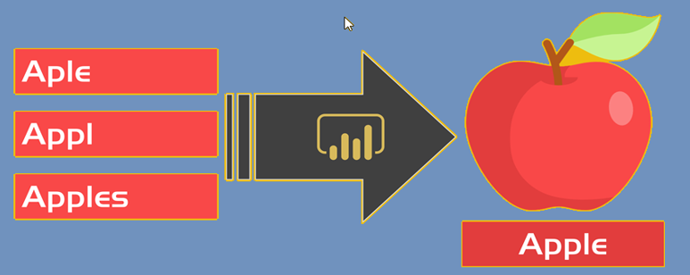

Fig: Google (Source)

**Fuzzy Search in SAP HANA:**

* Can be applied in the **WHERE** clause of a **SELECT** statement using the function ***‘CONTAINS’*** with the option ***‘FUZZY’***
* **SELECT** * **FROM** *<table_name>* **WHERE *CONTAINS*** *(<column_name>, <search_string>, FUZZY(x)).*
* **<table_name>** can be name of a column table, attribute view or a SQL view created with the CREATE VIEW statement
* **FUZZY(x)** specifies the degree of accuracy required between the strings used in comparison ***(<column_name> and <search_string>)***
* ‘x’ in FUZZY(x) is called a fuzzy factor and can have values between 0 and 1.

**Key Points:**

* If only ***FUZZY*** is specified, it takes the value of x as 0.8
* If ***FUZZY(x)/FUZZY*** is not provided, an exact match is searched.
* CONTAINS function can also be used in a SELECT query with JOIN.
* 0 being least accuracy and 1 being highest accuracy.

**What is AMDP Class?**

* An AMDP Class is a global class existing in the class library with a tag interface ***IF_AMDP_MARKER_HDB*** (to indicate AMDP classes for the HANA Database Server)
* Can contain both regular methods and AMDP methods
* A method is indicated as an AMDP method in the implementation section of the class using the addition ***BY DATABASE PROCEDURE***in the METHOD statement
* Can only be created using ADT.
* An AMDP method is called in an ABAP program in the same way as any other ABAP Objects method.

**How to implement Fuzzy Search using AMDP Class?**

Custom Table (ZSCARR) created as a part of this blog post and maintained the entries as shown in the below figures.

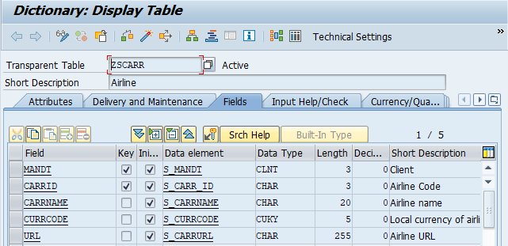

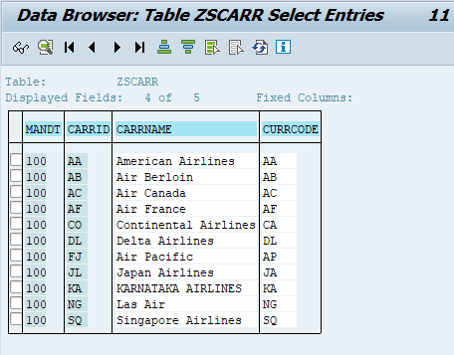

**Simple Use Case:**

Suppose you have 100000’s of record and you need to join multiple tables and fetch the output/data accordingly and the end user just wants to see the probable output based on the input provided by him. In this case, Fuzzy Search Technique comes handy.

* ***AMDP Class with Fuzzy Technique:***

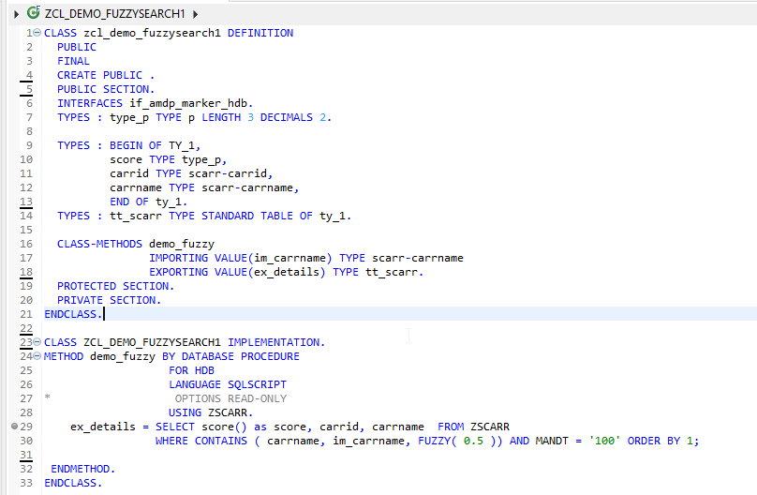

*Fuzzy Search AMDP Class*

* ***Consuming AMDP Class in Report Program:***

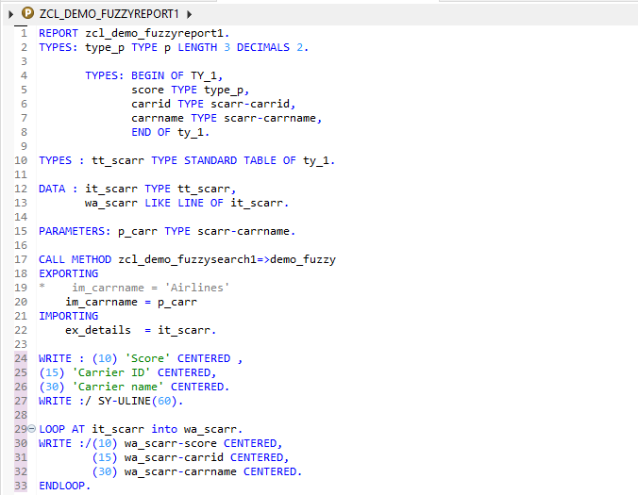

*Fuzzy Search Report Program*

**Selection Screen:**

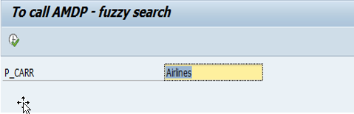

* **Output when Fuzzy is 0.1**

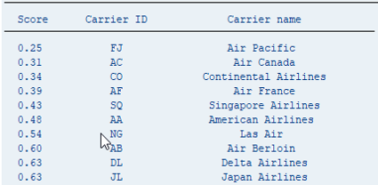

* **Output when Fuzzy is 0.5**

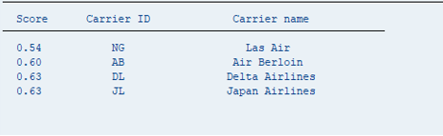

* **Output when Fuzzy is 1**

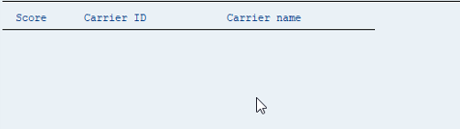

**Summary:**

* Fuzzy Search is a technique of finding strings that match a pattern approximately (rather than exactly).
* Fuzzy Search in SAP HANA makes use of two functions – CONTAINS () which performs search on strings and SCORE () which returns fuzzy score.